Society News + School Wide
_________________________________________________________________
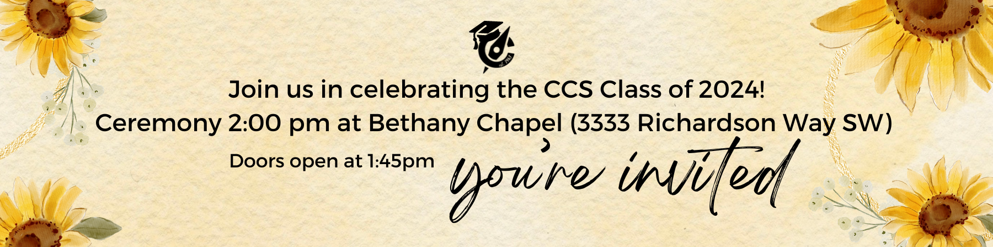

Talk Tuesday scheduled for June 25 is delayed. If you are interested in talking 1-on-1 Pastor Layne, please send him an email to set up a time.

Lost & Found: There are many items at both campuses needing to find their home! If items are not collected by the last day of school, they will be sent to donation.

School Cash & Hot Lunch: Please make sure to pay your outstanding balance on School Cash and Hot Lunch by June 26, 2024, the last day of school. Thank you.

Farewell: It is with mixed emotions that we announce the resignation of our Admissions Coordinator, Teena McAuley, effective August 31, 2024. After almost eight dedicated years with our organization, Teena has decided to pursue other interests and opportunities. We will miss her welcoming and cheery personality. With that being said, we are now looking for a new admissions coordinator! Please view the job description on our website here and apply today!

Development Office Update: Marianela Damen, Director of Development has recently left CSCE. Any ongoing communications should be directed to info@calgarychristianschool.com.

Pre School News
_________________________________________________________________
*click the image for more information and share it with a friend!

Elementary News
_________________________________________________________________

Early Dismissal Tomorrow: Tomorrow is the last day of school for Elementary Students. Dismissal is at 12:40 pm. Buses will pick up bus students at 12:40 pm to take them home.

Year End Chapel: Families are welcome to join our final Chapel tomorrow at 8:45am.

Kindergarten Admissions: If you know of someone who would be a good fit for CCS and they are still looking for a kindergarten placement, please have them inquire by filling out this form so that our admissions coordinator can reach out to them.

Student Banking: We are looking for a new Student Banking volunteer for the 2024-2025 School year. Responsibilities include monthly bank deposits and paperwork for new account opening. The time commitment is approximately 2-3 hours per month and training will be provided. If this is something you are interested in, please contact Meagan Bassett.

CCES 24/25 School Calendar is available here.

CCES Staffing Updates
Farewells:
- Mark Heppner: After nearly 20 years at CCS, Mark Heppner is moving on to new adventures. Mark has loved teaching at CCS and will miss everyone dearly. We wish Mark all the best!
- Danielle Hussey: All the best to Danielle Hussey who is now on maternity leave.
- Caroline Schollaardt: All the best to Caroline who is retiring! It has been both a privilege and a blessing to serve families as we have partnered together in the learning journey of children over the years. Thank you for entrusting your precious ones to me each day! As I leave this community of faith, know that I will pray for a restful summer for you all, and a smooth transition into a new group of classmates and teachers in the fall. Together we will continue to stand on God's promise from Psalm 37:5, "Commit your way to the LORD; trust in him and he will do it."
- Shannon Williams: Shannon Williams is going on leave for the 2024-2025 school year. We will miss you, Mrs. Williams!
- Nicole Yu: Nicole (our French teacher) will be moving onto new opportunities and her own homeroom at a different school, she will miss the CCES students and community greatly and hopes to visit from time to time!

Welcomes:
- Davis van Dyk: Welcome back to Davis who will be teaching in grade 4 next school year!
- Grace Ermter: Welcome back to Grace who will be our Early Numeracy Intervention teacher.
- Sarah Hansen: Warm welcome to Sarah Hansen in PE! My name is Sarah Hansen and I have taught for 9 years with Edmonton Public and Rocky View. I am passionate about physical literacy and numeracy and can’t wait to be a part of the team! I look forward to collaborating with teachers from a Christian background and meeting new brothers and sisters in Christ. I love the outdoors, hiking, sports, traveling, baking sourdough, gardening, and volunteering with local non-profits.

Secondary News
_________________________________________________________________

Class of 2024: Please join us tomorrow, June 26, to honor our graduates! The ceremony will take place at 2:00 pm at Bethany Chapel (3333 Richardson Way SW) and all are welcome!

CCSS Staffing Updates
Farewells
- Kate Stewart is taking a leave of absence for the 24/25 school year.
- Rob Oostenbrink is retiring after an amazing career here at CCS.
- Melissa Hair is moving on to new opportunities after her maternity leave.
Welcome
- Adrianna Moffat is joining us in the area of grade 9/10 humanities.

Textbook Returns: Please remind your child(ren) that all textbooks, English Language Arts novels, and library books are due and must be returned immediately. Please note that after June 26th, unreturned items will be considered lost and a replacement fee will be attached to the student's School Cash account.

Final Report Cards: Report cards will be published on June 28th through the Edsby app. Please ensure you have access to your account prior to the office closing for the summer. Report cards can be viewed on either your Edsby parent or your students' account.

June Exam Schedule is available here. Please take special note of the year end details for grade 7/8 which are as follows:
- No scheduled classes for grade 7/8 students on June 26. If a student still has outstanding assignments to complete, they may do so in school on this day. Keep in mind that the school buses have a different schedule to and only leave from the Elementary School tomorrow at 12:40 pm. No pick-up at the Secondary Campus.
Are you ready for grade 10 math? If you enter with solid foundational skills, your likelihood of success is extremely high. You may be interested in looking at this list of important underlying skills. Should any of these require supplemental support, there is a video lesson with accompanying practice questions, complete with solutions. Build your confidence and put yourself in the best possible position to reach your academic goals. For more information, check out this link.

2024/25 School Calendar is available here.

Missed last week’s communication? Find it here: Weekly Email

UPCOMING:
June 26 - Grade 12 Graduation

